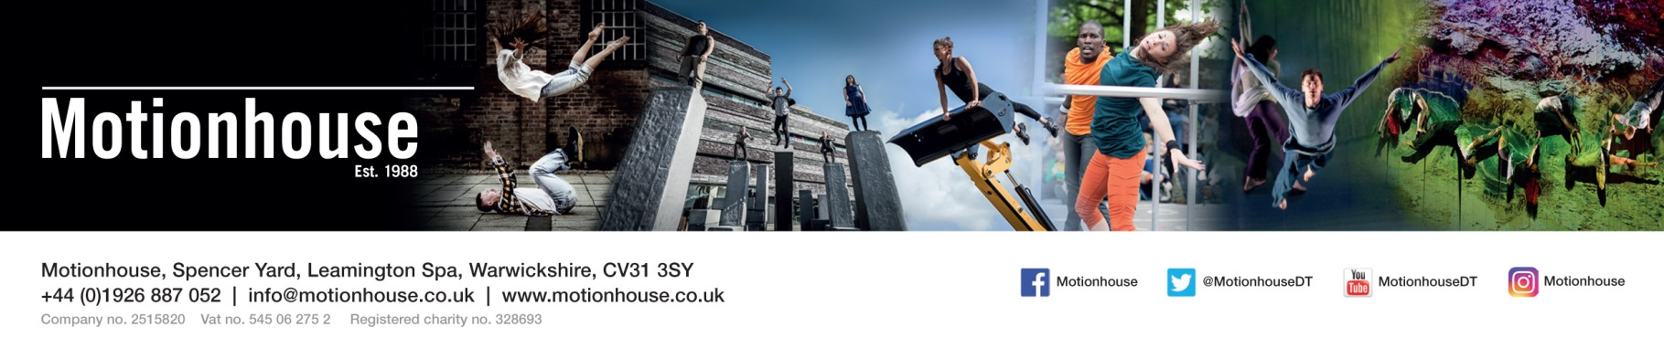

Thank you for your interest in spending some time with Motionhouse. As I’m sure you will appreciate, we receive many requests for work placements and professional development placements and although we try and accommodate as many people as possible, due to the nature of being a busy touring company we cannot accept everybody.
We do not have funding available to support students looking to complete their work placement with Motionhouse so please be sure you’re able to finance your own travel and accommodation if necessary.
In order for us to consider your request we would ask you to complete the attached form and then return it to us by either email or post.
Email: info@motionhouse.co.uk
Post: Motionhouse, Spencer Yard, Leamington, CV31 3SY
We look forward to hearing from you.

REQUEST FOR WORK PLACEMENT APPLICATION

NAME: ……………………………………………………………………... AGE: …...........................................
ADDRESS: ………………………………………………………………….
…………………………………………………………………..
………………………………………………………………….. POSTCODE: ……………………………….
EMAIL: …………………………………………………………………… TEL: …………………………………………..

ARE YOU A STUDENT/ GRADUATE? (PLEASE DELETE AS NECESSARY)
NAME OF SCHOOL/COLLEGE/UNIVERSITY: ………………………………………………………………………………….
NAME OF COURSE: ……………………………………………………………………………………………………………………
CURRENT YEAR (eg 1st year): ……………………………………………………………………………………………………

PROFESSIONAL EXPERIENCE: …………………………………………………………………………………………………....
………………………………………………………………………………………………………………………………………………………………………………………………………………………………………………………………………………………………………………………………………………………………………………………………………………………………………………………

OTHER RELEVANT EXPERIENCE: …………………………………………………………………………………………………………………
………………………………………………………………………………………………………………………………………………………………………………………………………………………………………………………………………………………………………………………………………………………………………………………………………………………………………………………

PLEASE STATE THE DATES YOU WOULD LIKE TO COME TO MOTIONHOUSE: …………………………………
…………………………………………………………………………………………………………………………………………………

PLEASE STATE WHICH DEPARTMENT YOU WOULD LIKE TO BE PLACED WITH WHILST ON YOUR PLACEMENT:
DANCERS MARKETING TECHNICAL ADMIN EDUCATION

PTO..

PLEASE TELL US WHAT YOU WOULD HOPE TO GAIN FROM YOUR PLACEMENT WITH MOTIONHOUSE: ………………………………………………………………………………………………………………………………………………………………………………………………………………………………………………………………………………………………………………………………………………………………………………………………………………………………………………………………………………………………………………………………………………………………………………………………………………………………………………………………………………………………………………………………………………………………………………………………………………………………………………………………………………………………………………………………………………………………………………

WHAT SKILLS/CONTRIBUTION DO YOU THINK YOU COULD OFFER MOTIONHOUSE:
……………………………………………………………………………………………………………………………………………………………………………………………………………………………………………………………………………………………………………………………………………………………………………………………………………………………………………………………………………………………………………………………………………………………………………………………………………………………………………………………………………………………………………………………………………………………………………………………………………………………………………………………………………………………………………………………………………………………………………….

Signed…………………………………………. Date………………………………………………………

