About Motionhouse
Pushing movement to its limits since 1988

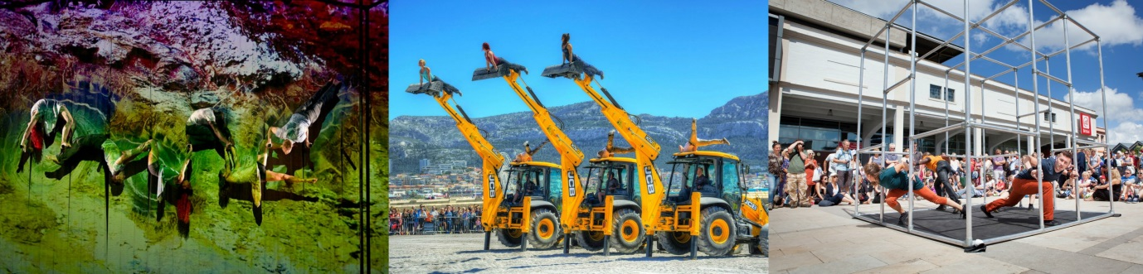

Founded in 1988 by Louise Richards and Kevin Finnan MBE, we create world-class dance-circus productions that tour extensively to rave reviews across the globe. From full-length productions for theatre touring to flexible work for the outdoors and large-scale performance events, our sell-out productions integrate athletic physicality, powerful narrative, incredible digital imagery and emotive sound scores.
Our work takes its inspiration from common human concerns and our connection to the world in which we live, with recent works exploring flooding, the pressure of time, fear and captivity, and our relationship with water, the Earth and energy. Our dancers perform on stunning sets, alongside JCB diggers, with aerialists and singers, in incredible settings and to breath-taking effect.

Theatre productions
Our full-length productions tour to theatres across the UK and internationally. We seamlessly integrate digital imagery with live performance, creating a ‘living film’ that draws audiences into the magical world on stage. Powerful and emotive, these productions inspire and move; generating repeat tours, large audiences and reinforcing our reputation as an outstanding touring company. Recent years have seen two highly acclaimed US tours, as well as tours of mainland China, Hong Kong, Macau, Japan, and regular appearances throughout Europe.

Outdoor productions
Pioneers of outdoor dance, our range of flexible productions tour to festivals and non-theatre spaces. These short, sharp injections of dance and circus are designed to be performed outdoors and up-close rather than in a conventional theatre. Immensely popular on the international festival circuit, we tour this work extensively to enormous crowds and great acclaim, inspiring audiences who are not necessarily familiar with dance. These works are also increasingly popular for corporate and other events. We are currently touring a series of outdoor productions that range in scale and duration from an intimate 9-minute duet to a 45-minute dance-circus collaboration with NoFit State Circus on giant Jenga blocks and a series of larger-scale spectacles incorporating dancers and JCB diggers.

Large-scale events
With a three-decade track record of creating work in unusual settings, we have secured a reputation as the ‘go to’ company to create visionary large-scale outdoor events. From beaches to stately homes and from animating a working harbour to bringing an inner city wasteland to life, as well as being commissioned to celebrate the London 2012 Olympic Games from bid success through launch to opening, we are renowned for our spectacular large-scale outdoor events. Our Artistic Director Kevin Finnan MBE was Choreographer and Movement Director for the Opening Ceremony of the London 2012 Paralympic Games.

Inspiring the next generation
We have an enviable reputation for delivering an excellent programme of education and training at our studio in Leamington Spa, throughout the UK and further afield. We deliver a wide range of learning and training projects, in schools and in the community, for students and for young professionals, focusing on skills-development and creativity. Our teaching is accessible and inspiring and emphasises a sense of achievement for all. We offer a range of activities for all ages and abilities and frequently offer the opportunity to develop creative work for performance. See our classes page for both weekly and regular holiday classes at our home base and explore our learn and train pages to find out more about the range of opportunities we offer.

Motionhouse is supported using public funding by the National Lottery through Arts Council England.
www.motionhouse.co.uk
Contact: Jane Bailey – jane@motionhouse.co.uk

