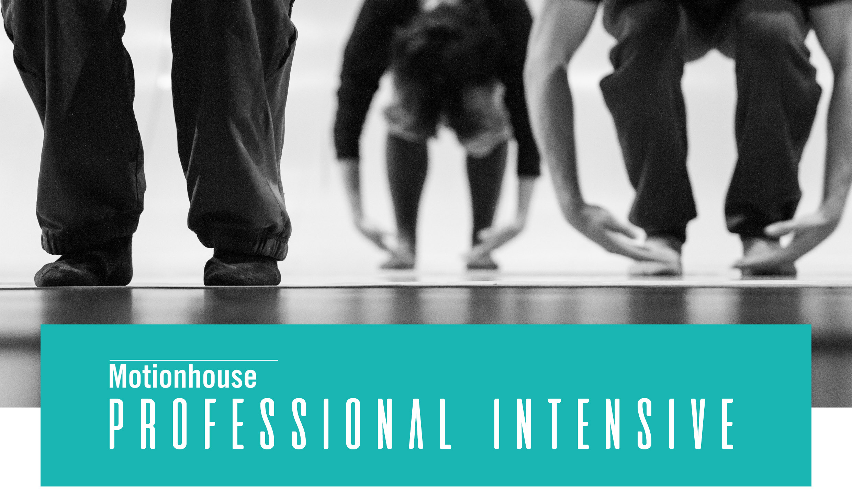

Application Form

Personal Details

Full name:

Date of birth:

Sex (male / female / prefer not to say):

Nationality:

Telephone number:

Email address:

Address:
Postcode:

Current occupation
Please select:
☐ Dance professional
☐ Undergraduate student
☐ Postgraduate student

Education and Training

Please include any dance related qualifications/grades you may have, including dates and name of schools attended:

Performance experience
Please give us a brief outline of your performance experiences to date:

Self Development
Please tell us why you would like to take part in our Professional Intensive:

