This is an accessible route to our rehearsal space at the Vitsoe building from Leamington Spa railway station.
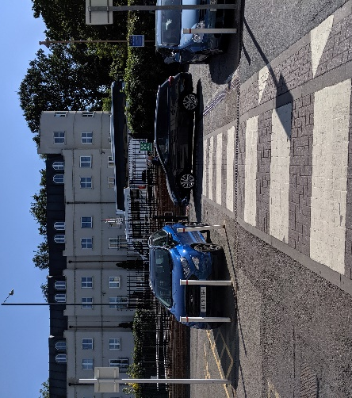 | When you exit the Leamington Spa railway station building cross over the pedestrian crossing that is immediately outside the main exit.
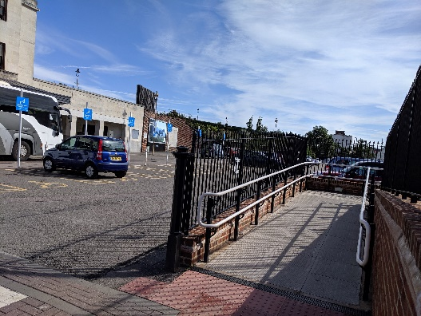 | Then take the pedestrian ramp to your left to exit onto the main road.
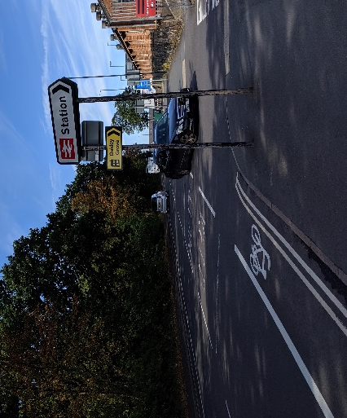 | Turn right on the A425 and walk past the sign for the station and the entrance for vehicles.
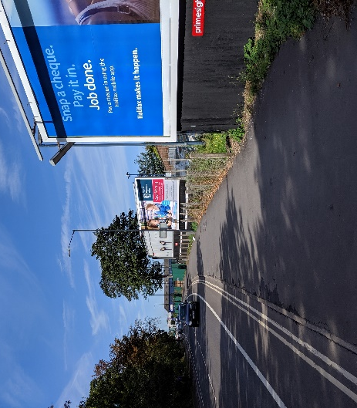 | Continue on the A425, past the three billboards on your right.
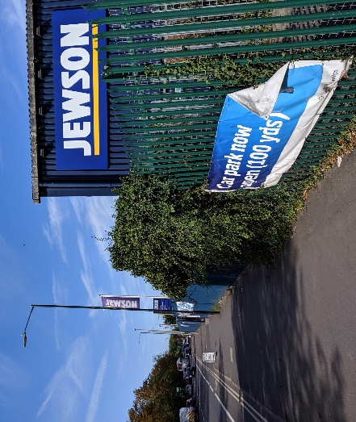 | Keep going straight past Jewson on your right.
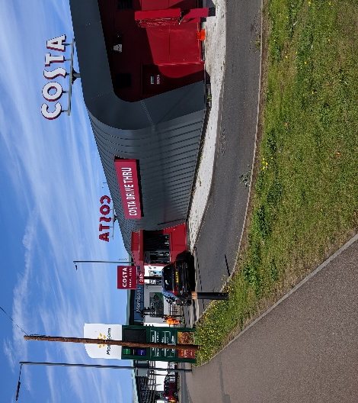 | Continue straight past Costa Coffee on your right.
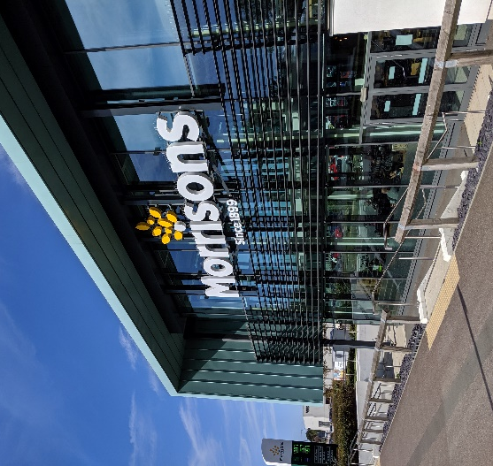 | You will see a Morrisons supermarket on your right, keep going straight past the supermarket.
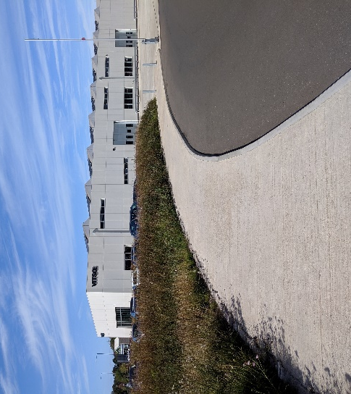 | Opposite Morrisons supermarket is a white building which is the Vitsoe building. Turn right on the path to the Vitsoe building and walk up to the automatic doors at the end of the path.
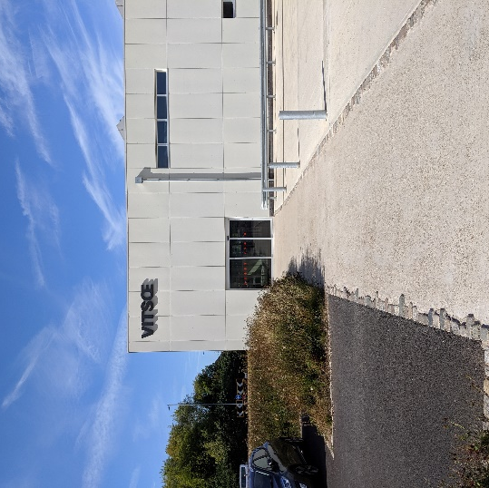 | You have arrived at our rehearsal space, Vitsoe! Ring the bell and one of the Motionhouse team will come and invite you in.

