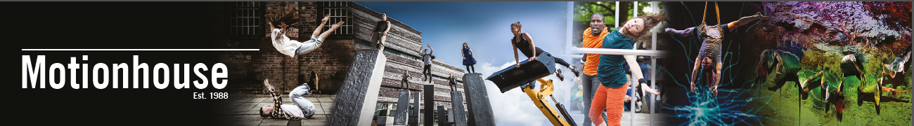
Technician Job Pack

About Motionhouse
Incredible dance-circus: pushing movement to its limits since 1988
Based in Leamington Spa since 1988, we create and tour a wide range of inspiring and powerful dance-circus productions to theatres and festivals in the UK and across the globe. Our distinctive, highly physical style integrates elements of circus and acrobatics with breath-taking dance to surprise and delight our audiences, using powerful narrative and incredible digital imagery. Our accessible dance-circus style attracts large audiences, in a normal year, performing to 120,000+ people. Pioneers of outdoor dance, we take world-class dance-circus to audiences in a range of settings, from full-length touring theatre productions to outdoor work at festivals or in the street, in the heart of people’s communities, reaching children, young people and families, free of charge, in some of our most deprived communities. We also offer a vibrant programme of education and training activities for all ages, including classes, post-show discussions, workshops in schools and a range of professional development opportunities.
Motionhouse was founded by Executive Director Louise Richards and Artistic Director Kevin Finnan MBE who still lead the company. With an ethos that dance is for everyone, our mission is to make world-class dance accessible to all. We believe that dance has the power to illuminate the human condition and to change lives, enriching our emotional world and making a positive impact on educational and cognitive development and on health and wellbeing.
We work collaboratively with an extensive network of partners in dance, the arts, digital industries, universities, colleges, schools, and the community, with many partnerships, particularly in our home region of the West Midlands. Our distinctive contribution to UK dance is recognised by our inclusion in Arts Council England’s National Portfolio. We have an experienced Board of Trustees with strong governance expertise. We are a mature, resilient and creative organisation, a resourceful arts business and effective charity, with a track record in shaping how dance is defined and performed, in training the dancers of the future, offering life-changing participatory activities and inspiring teaching: enriching lives through the transformative power of dance regardless of age, ability, background or financial means.
Current context
You will be joining the company at a pivotal time as we continue to rebuild after the impacts of Covid-19. Having had all bookings cancelled in 2020 and the first half of 2021 due to government restrictions, we decided to ‘Come back dancing’ as illustrated in this video. With bookings in place for our outdoor work this summer, the continuation of our extensive UK and European tour of Nobody, and another new show premiering in October this is an exciting time to join us. If you would like to be part of this important moment for the company, please get in touch.
Where we are based
We have two exciting spaces at the heart of Leamington Spa in Warwickshire. In 2020 we moved into a new creation and rehearsal space in Leamington Town Hall. Our move was part of wider plans by Warwick District Council in their Creative Framework that puts creativity at the heart of the town’s programme to offer residents an enriching place to live. We run our youth and community programme from our office and studio space in Spencer Yard, located at the heart of the new Creative Quarter currently under development. Leamington is a vibrant and diverse town, home to a wide range of people who work in businesses based locally – from Jaguar Land Rover and Aston Martin, to around 20 leaders in the video game industry, the National Grid, the University of Warwick, Bravissimo and many more. It offers a range of high street chains as well as thriving local shops, cafes and restaurants. It is well connected by train and road, with the M40 arriving directly and a link to the M1 and M6 not far. Coventry is a 15 minute drive or train journey, and there is an excellent and regular train service to Birmingham (30-45 mins) and London (1h15-1h30).
Watch the trailer for Nobody and see our showreel of exciting work.
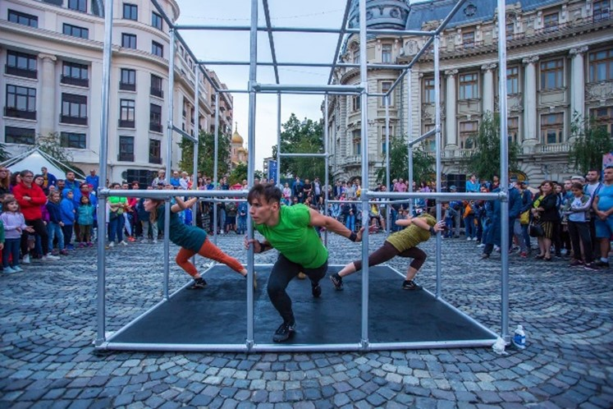
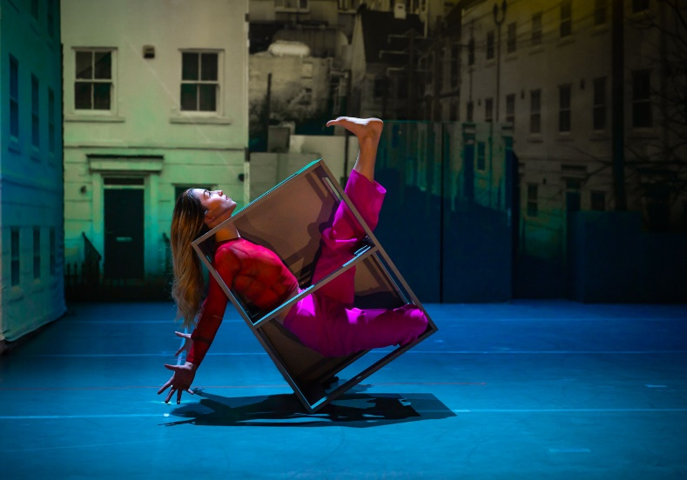
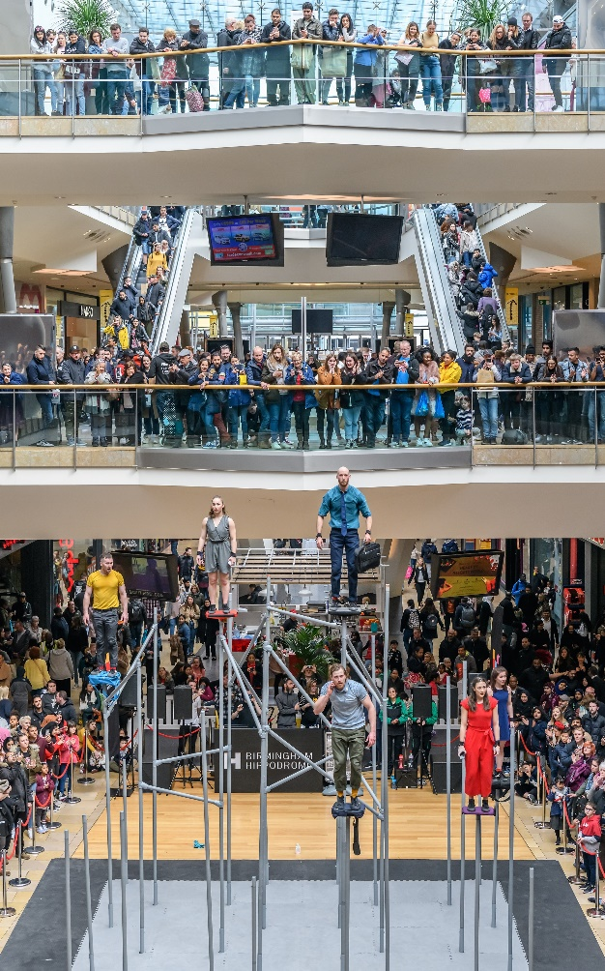
Examples of our dynamic and powerful outdoor and theatre productions.
Audiences enjoy Captive at B-FIT in the Street Festival, Bucharest, Romania. Image B-FIT
WILD attracts large crowds of shoppers in the Bullring, Birmingham. Image Simon Hadley.
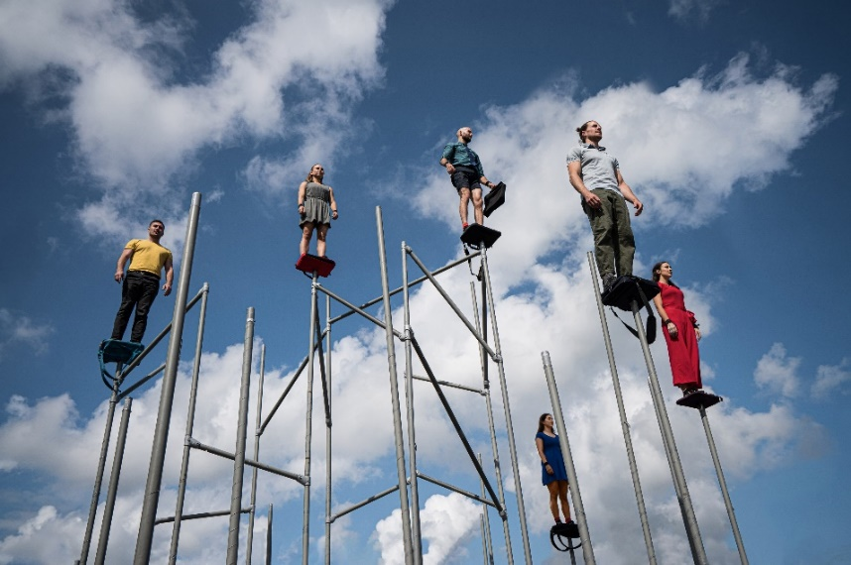

Top left, Nobody and here WILD, captured by Dan Tucker
Technician Job Description

Motionhouse is looking to appoint a full time Technician, managed by our Technical Manager, to support technical delivery of all aspects of our busy programme.

Working in collaboration with the wider team the role will support the delivery of productions across our programme, varying in scale from small to large, in both traditional venues and outdoor settings.
Areas of responsibility:
- Support the Technical Manager to deliver all technical production requirements for tours and productions, including but not limited to, Lighting, Sound, Stage, AV and Rigging.
- Where delegated by the Technical Manager, to take the lead for specific assigned events.
- Tour widely as part of the Motionhouse technical crew.
- Interface with the company and venue staff to ensure the safe installation, operation, and smooth running of all aspects of the production.
- Call shows and take responsibility for the welfare of the dancers whilst on the road.
- On tour and during creation phases, to facilitate Get ins and outs, including safe loading and unloading of the Company’s 7.5T truck and/or Sprinter van to venues, rehearsal space and to any 3rd party freight or haulage company where necessary.
- Organise projection and lighting kit to go out for touring shows.
- Set up and operation of stage sets, projection, lighting, and sound equipment in rehearsal and on tour.
- Calling and operating any cues and entrances during dress and tech rehearsals and performance as required.
- Implement scene changes, setting and removal of props as required.
- As instructed, undertake the focus of lighting to achieve the best possible look for each performance.
- Routine maintenance of the rehearsal space and technical support for the company whilst in creation of new productions and in general rehearsal.
- Support the Technical Manager in the testing and maintenance of all sets and equipment, including but not limited to PAT Testing and LOLER inspection.
- Undertake routine checks to company vehicles and report any potential mechanical issues to the team as soon as possible.
- Routinely undertake stock takes and inventory on the road to ensure the company have all required consumables for the delivery of the show.
- Any other reasonable tasks required to successfully execute the role.

Technician – Person Specification

Essential Criteria | Desirable Criteria
Experience working in the live events or performing arts sector.  Basic working knowledge of setting up stage, Sound and Lighting for Performing Arts.  Experience in stage management and technical show operation of lighting and sound.  Experience working with lighting equipment including routine maintenance and repair.  Basic knowledge and understanding of temporary power installations and safe rigging practices.  Experience driving large vans, and willingness to undertake further training to drive our 7.5T HGV if appropriate.  Knowledge and experience of working at height, safe handling of equipment whilst loading in and out, and adhering to safe working practices at all times.  Valid Passport and Driving licence. | Experience with ETC Lighting control desks, QLab and Basic projection mapping software.  Experience working with aluminium Trussing.  Experience working with AV  Experience or interest in Vectorworks Plan drafting, 3D and 2D.  Experience working with tools and basic soldering skills.  Good knowledge and ability to operate ETC consoles including the company’s Gio@5 Console.  Basic knowledge of wireless DMX systems and battery-operated LED lighting.  First Aid Qualified.

Further information
Salary £24,000 to £27,000 per annum, paid on a monthly basis. There is a company pension scheme.
Working hours variable and in line with ITC/Equity agreement.
Holiday 25 days plus statutory holidays (or days in lieu of these)
Overtime We operate a time off in lieu system.
Probationary period Six months
Notice period 2 weeks within probation period. Three months thereafter.
Usual place of Employment
Motionhouse rehearsal spaces, office and storage are all in Leamington Spa. Touring travel starts and finishes at company base. More information on how to find Motionhouse is available here: https://www.motionhouse.co.uk/contact/find-us/
Applicants must be based in or prepared to move to the West Midlands.
Motionhouse champions equality and is committed to creating a culture that respects and values diversity, inclusivity and equality. We welcome applicants from all sections of society and positively encourage applications from people who are underrepresented in our sector, including those from working class and ethnically diverse backgrounds or who experience racism, people who are neurodivergent, people with disabilities and people from the LGBTQ+ community.
Application Procedure

To apply please email your application to Programme Producer, Victoria Collins (victoria@motionhouse.co.uk).

You should send a covering letter or video/voice note of no longer than 5 minutes, setting out clearly how you meet the person specification for the post, detailing relevant experience and your ability to deliver the duties set out in the job description. Let us know why you would like to work for Motionhouse. Please also attach your CV and the application form, which is available here.

In preparation for your application, and for more information about the company we recommend that you visit www.motionhouse.co.uk

Closing Date for Applications: 9am on Monday 14th February

Shortlisted applicants will be invited to interview on Friday 18th February. If you cannot make this date, please make this clear at point of application.

Start date: 21st March 2022

For more information on our work, videos, images and trailers, go to:
www.motionhouse.co.uk

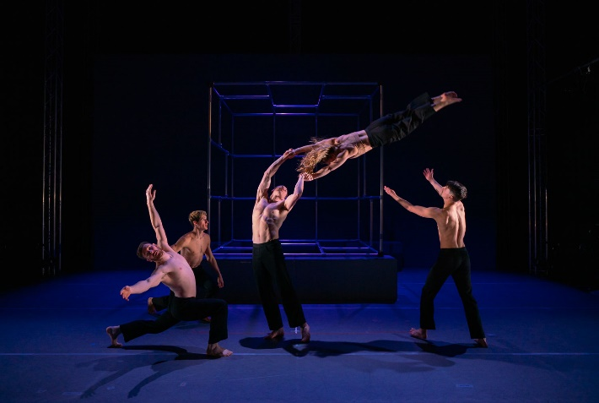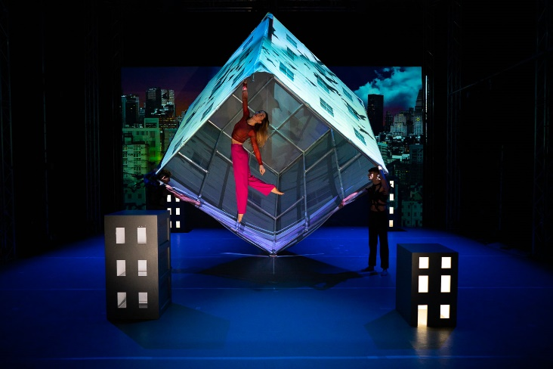
Nobody, captured by Dan Tucker

