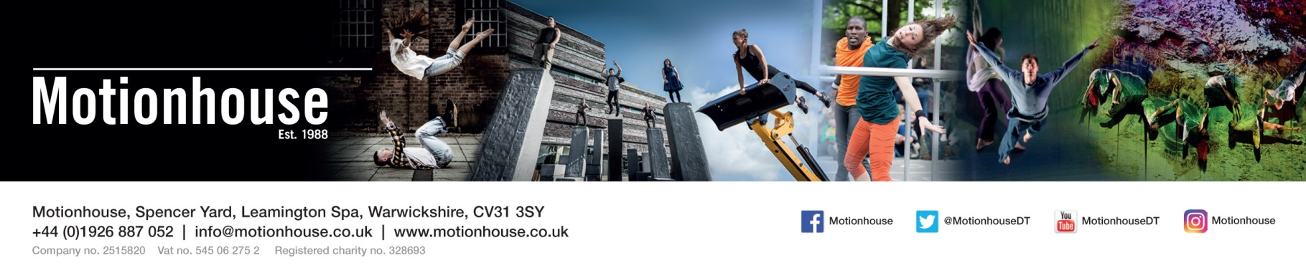

Thank you for your interest in spending some time with Motionhouse. As I’m sure you will appreciate, we receive many requests for work placements and although we try and accommodate as many people as possible, due to the nature of being a busy touring company we cannot accept everybody.
We do not have funding available to support students looking to complete their work placement with Motionhouse so please be sure you’re able to finance your own travel and accommodation if necessary.
In order for us to consider your request we would ask you to complete the attached form and then return it to us by either email.
Email: info@motionhouse.co.uk
We look forward to hearing from you.

REQUEST FOR WORK PLACEMENT APPLICATION
NAME: Click or tap here to enter text. AGE: Click or tap here to enter text.
ADDRESS: Click or tap here to enter text.
POSTCODE: Click or tap here to enter text.
EMAIL: Click or tap here to enter text. TEL: Click or tap here to enter text.

ARE YOU A STUDENT/ GRADUATE? (PLEASE DELETE AS NECESSARY)
NAME OF SCHOOL/COLLEGE/UNIVERSITY: Click or tap here to enter text.
NAME OF COURSE: Click or tap here to enter text.
CURRENT YEAR (eg 1st year): Click or tap here to enter text.
PROFESSIONAL EXPERIENCE:

OTHER RELEVANT EXPERIENCE:

PLEASE STATE THE DATES YOU WOULD LIKE TO COME TO MOTIONHOUSE: Click or tap here to enter text.

PLEASE STATE LENGTH OF TIME YOU WOULD LIKE TO COME TO MOTIONHOUSE:

1 – 4 DAYS ☐ 1 WEEK (5 DAYS) ☐ 2 WEEKS (10 DAYS) ☐ OTHER: Click or tap here to enter text.

PLEASE STATE WHICH DEPARTMENT YOU WOULD LIKE TO BE PLACED WITH WHILST ON YOUR PLACEMENT:
DANCERS ☐ MARKETING ☐ ADMIN ☐ EDUCATION ☐
PLEASE TELL US WHAT YOU WOULD HOPE TO GAIN FROM YOUR PLACEMENT WITH MOTIONHOUSE:

WHAT SKILLS/CONTRIBUTION DO YOU THINK YOU COULD OFFER MOTIONHOUSE:

Signed…………………………………………. Date: Click or tap here to enter text.

